Creating Microservices for Account and Loan

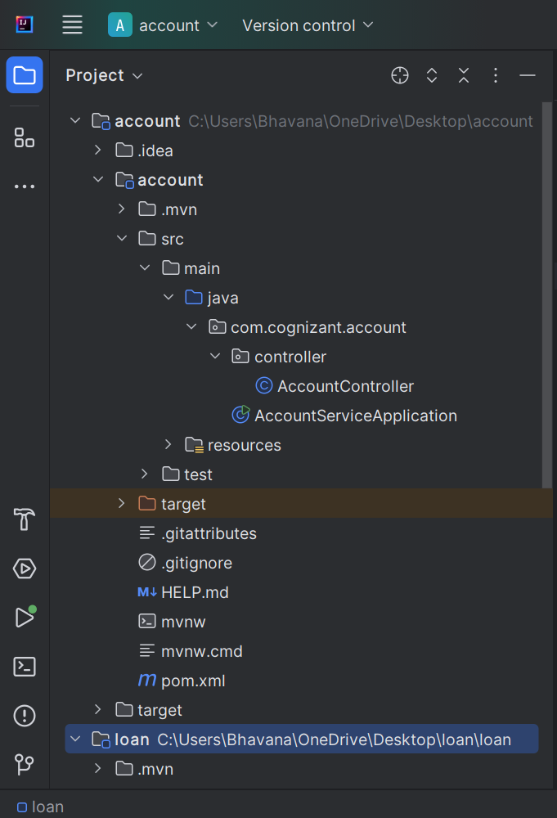

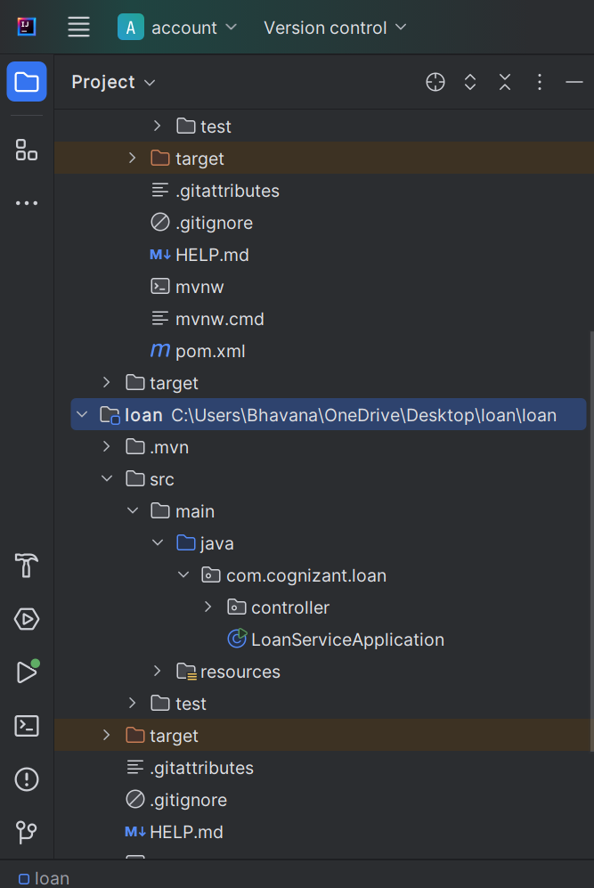

AccountServiceApplication.java
package com.cognizant.account;
import org.springframework.boot.SpringApplication;
import org.springframework.boot.autoconfigure.SpringBootApplication;
@SpringBootApplication
public class AccountServiceApplication {
public static void main(String[] args) {
SpringApplication.run(AccountServiceApplication.class, args);
}
}

AccountController.java
package com.cognizant.account.controller;
import org.springframework.web.bind.annotation.*;
import java.util.HashMap;
import java.util.Map;
@RestController
@RequestMapping("/accounts")
public class AccountController {
@GetMapping("/{number}")
public Map<String, Object> getAccountDetails(@PathVariable String number) {
Map<String, Object> response = new HashMap<>();
response.put("number", number);
response.put("type", "savings");
response.put("balance", 234343);
return response;
}
}

Application.properties
spring.application.name=account
server.port=8080

Pom.xml
<?xml version="1.0" encoding="UTF-8"?>
<project xmlns="http://maven.apache.org/POM/4.0.0" xmlns:xsi="http://www.w3.org/2001/XMLSchema-instance"
xsi:schemaLocation="http://maven.apache.org/POM/4.0.0 https://maven.apache.org/xsd/maven-4.0.0.xsd">
<modelVersion>4.0.0</modelVersion>
<parent>
<groupId>org.springframework.boot</groupId>
<artifactId>spring-boot-starter-parent</artifactId>
<version>4.1.0</version>
<relativePath/> <!-- lookup parent from repository -->
</parent>
<groupId>com.cognizant</groupId>
<artifactId>account</artifactId>
<version>0.0.1-SNAPSHOT</version>
<name/>
<description/>
<url/>
<licenses>
<license/>
</licenses>
<developers>
<developer/>
</developers>
<scm>
<connection/>
<developerConnection/>
<tag/>
<url/>
</scm>
<properties>
<java.version>17</java.version>
</properties>
<dependencies>
<dependency>
<groupId>org.springframework.boot</groupId>
<artifactId>spring-boot-starter-webmvc</artifactId>
</dependency>
<dependency>
<groupId>org.springframework.boot</groupId>
<artifactId>spring-boot-starter-webmvc-test</artifactId>
<scope>test</scope>
</dependency>
</dependencies>
<build>
<plugins>
<plugin>
<groupId>org.springframework.boot</groupId>
<artifactId>spring-boot-maven-plugin</artifactId>
</plugin>
</plugins>
</build>
</project>

LoanServiceApplication.java
package com.cognizant.loan;
import org.springframework.boot.SpringApplication;
import org.springframework.boot.autoconfigure.SpringBootApplication;
@SpringBootApplication
public class LoanServiceApplication {
public static void main(String[] args) {
SpringApplication.run(LoanServiceApplication.class, args);
}
}

LoanController.java
package com.cognizant.loan.controller;
import org.springframework.web.bind.annotation.*;
import java.util.HashMap;
import java.util.Map;
@RestController
@RequestMapping("/loans")
public class LoanController {
@GetMapping("/{number}")
public Map<String, Object> getLoanDetails(@PathVariable String number) {
Map<String, Object> response = new HashMap<>();
response.put("number", number);
response.put("type", "home");
response.put("loanAmount", 550000);
return response;
}
}

application.properties
spring.application.name=loan
server.port=8081

OUTPUT:
